Volume: 25 June 4, 2023 Number: 23
Rendon Church of Christ 12220 Rendon Rd. --- Burleson, TX. 76028 Ph. 817-483-1240

Live Broadcasts
We are broadcasting our worship services over the Internet.

Our website address:
https://rendonchurchofchrist.com/
Also find us at OABS.org - Go to
Congregation>Rendon>Website

Email address:
rendonchurchofchrist@gmail.com
Phone 817-483-1240
You can find us on both YouTube and Facebook
Check out this web site:
BibleWayMedia.org
(We help support this work.)

Schedule Of Services
Sunday
Bible Study 9:30 A. M.
Worship 10:30 A. M.
Worship 4:00 P. M.
2nd Sunday Potluck following the morning service. At 1:15 we will have a singing service.
Tuesday:
Ladies Class -- 10 A. M. (Sept. – June)
Wednesday
Midweek Services: 7:30 P. M.
Our Preacher:
Toney L. Smith – (817) 483-1240

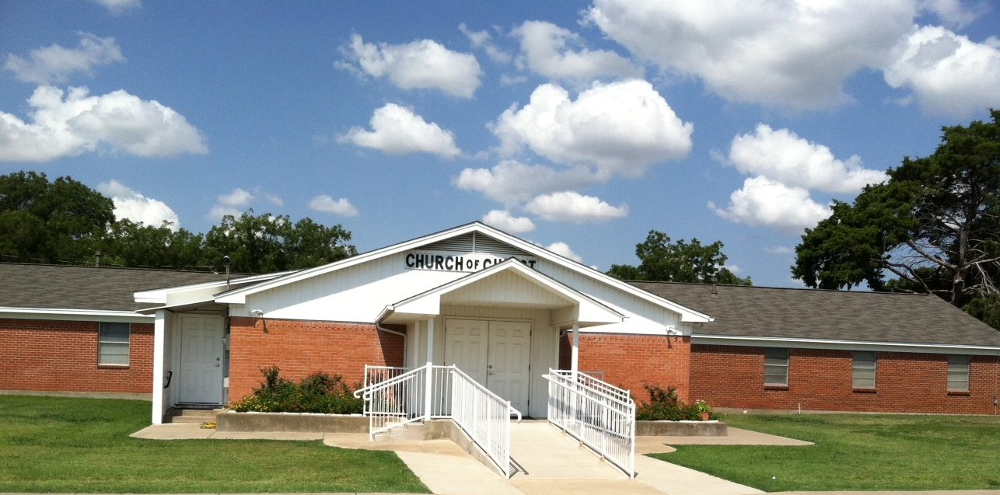
The Encourager

:

Welcome to Our Visitors
Thank you for choosing to worship with us. We would like to have a record of your attendance. Please fill out a visitor card. We look forward to seeing you again.

Prayer List:
Sophia Kersten, Delpha Pearce, Brandy Smith, Edith Smith, Sherra Reeves, Kay Johnston, Geneice and Derral, Robbie and Edwina, Darlene Scott, Tip and Phillis.
Keith Pilgrim has been deployed.
Family and Friends:
Ernesto Casas, Tim Bridges, Curtis Lallance, Justin Siklosi, Leanna Shafer, and Galen Anderson. Danna Johnson and David Lemmons friends of Toney and Debby. Both are being treated for cancer.

Sermon Titles for today:
AM: All Things New (2 Cor. 5:17).
PM: Questions & Answers.

Works Rendon Supports:
Chuck Northrop: OABS Director.
Online Academy of Biblical Studies.
Oologah, OK Internet Radio.
Cherokee Children’s Home.

God’s Plan For Salvation
Hear: Rom. 10:17.
Believe: Mark 16:16.
Repent: Luke 13:3, 5.
Confess: Rom. 10:9-10.
Baptism: Acts 2:38.
Be Faithful: 1 Cor. 15:58.
There is no other way!

Rendon Church of Christ
12220 Rendon Rd.
Burleson, TX. 76028

“Therefore, if any man be in Christ, he is a new creature: old things are passed away; behold, all things are become new.” (2 Corinthians 5:17). “… even so we also should walk in newness of life.” (Romans 6:4).


In the Military:
Keith Pilgrim and Justin Cormier.

Living Sacrifices
Toney L. Smith
Every Christian is to be a living sacrifice for Christ (Rom. 12:1-2). In this challenging call to Christian living, Paul is emphasizing the need to be set apart from all ungodly living. He is saying, “live differently than the world.” Someone once said, “Total sacrificial living is life indeed.”
The saint is to be a living sacrifice. The Old Testament required the bloody sacrifice of animals (Heb. 10:1). In the New Testament we are not admonished to make these animal sacrifices, however, we are called upon to make a daily sacrifice of ourselves. We must lay down our lives for the Lord (Mat. 16:25). We must be willing to give up anything to be a disciple of Christ (Luke 14:33). The Macedonian Christians gave liberally of their money and goods to the Lord, but we must understand they “first gave their own selves to the Lord” (2 Cor. 8:5).
All of this means that the Christian is to keep himself from the things of the world which would take Him away from God. The temptations of that lifestyle can be overcome if we are willing to make a sacrifice. I have heard some say, “Do I have to give up everything to be pleasing to God?” Or some say, “That’s too restrictive.” Truth is, we must all make a sacrifice if we are to be holy in His sight.
the silent sermon.
A member of a certain church, who previously had been attending services regularly, stopped going. After a few weeks, the minister decided to visit him. It was a chilly evening. The minister found the man at home alone, sitting before a blazing fire. Guessing the reason for his minister’s visit, the man welcomed him, led him to a comfortable chair near the fireplace, and waited.
The minister made himself at home but said nothing. In the grave silence, he contemplated the dance of the flames around the burning logs. After some minutes, the minister took the fire tongs, carefully picked up a brightly burning ember and placed it to one side of the hearth all alone. Then he sat back in his chair, still silent. The host watched all this in quiet contemplation. As the one lone ember’s flame flickered and diminished, there was a momentary glow and then its fire was no more. Soon it was cold and dead.
Not a word had been spoken since the initial greeting. The minister glanced at his watch and realized it was time to leave, he slowly stood up, picked up the cold, dead ember and placed it back in the middle of the fire. Immediately it began to glow, once more with the light and warmth of the burning coals around it. As the minister reached the door to leave, his host said with a tear running down his cheek, “Thank you so much for your visit and especially for the fiery sermon. I shall be back in church next Sunday.” (Author Unknown)
does it mean anything?
Tim Smith
“The like figure whereunto even baptism doth also now save us” (1 Pet. 3:21). Does this passage of Scripture have a meaning? I am told by many that it does not mean that baptism is necessary, and that it does not mean that baptism saves, and it does not mean a lot of other things, but my question is: DOES IT MEAN ANYTHING? It was not put there to confuse us, for “God is not the author of confusion” (1 Cor. 14:33). It was not put there to deceive us, for deception is condemned by the Lord (2 The. 2:10-12). It was not put there “for no reason,” for “all scripture is given by inspiration of God” (2 Tim. 3:16). It is a part of Scripture, that body of truth which sanctifies (John 17:17), frees from sin (John 8:32), brings about unity (1 Cor. 1:10), and saves (Jam. 1:21). What does it mean? It means that baptism doth also now save us, just as it says. Baptism is for the remission of sins (Acts 2:38), for the washing away of sins (Acts 22:16), into the death of Christ (Rom. 6:3-4), and into the body of Christ (1 Cor. 12:13). Baptism saves, that is what it says, and that is what it means.

